In Partial Fulfillment of the Requirements for the
CS 223 - Object Oriented Programming

Pet Information System Documentation

Presented to:
Dr. Unife O. Cagas
Professor

Presented by:
Teriote, Nickel jay

BSCS-2A: Computer Science
May, 2024

Fruit Information System Documentation

Description
The Fruit Information System is a Python-based application designed to store, manage, and display information about various types of fruits. The system showcases essential object-oriented programming (OOP) principles such as inheritance, polymorphism, abstraction, and encapsulation. This project is intended for both educational purposes and practical use, providing a user-friendly interface for fruit enthusiasts to record and retrieve information about their fruits.
Objective
Demonstration of Object-Oriented Programming (OOP) Concepts:
•To illustrate key OOP principles such as inheritance, polymorphism, abstraction, and encapsulation through practical implementation in a Python application.
User-Friendly Interface:
•To offer an intuitive and easy-to-use text-based interface that allows users to input and retrieve fruits information effortlessly.
Extendibility and Flexibility:
•To design a flexible system architecture that can be easily extended to include additional types of fruits or more detailed fruit information in the future.
Accurate and Detailed Record Keeping:
•To enable accurate and detailed record-keeping of fruits attributes such as name, color, and ensuring all relevant information is captured.
Consistent and Standardized Output:
•To provide consistent and standardized output regarding fruit details, ensuring users receive clear and uniform information.

Importance and contribution
Application:
•Beyond its educational value, the system has practical applications for fruits seller, and fruits care facilities. It provides a convenient way to manage fruits records, making it a useful tool for real-world scenarios.
Code Reusability and Maintenance:
•By utilizing inheritance, the system promotes code reusability and simplifies maintenance. Common functionalities are defined in the base class fruits, while specific details are handled by subclasses (apple, banana, orange). This modular approach reduces code duplication and enhances maintainability.
Encouraging Innovation:
•The extendable nature of the system encourages developers to innovate and expand the application. By providing a solid foundation, it inspires further development and creative enhancements, fostering a culture of innovation.

Four principles of Object Oriented Programming
1. Encapsulation: demonstrated through the use of private attributes and public getter methods.
class Pet(ABC):
def __init__(self, name, color):
self.__name = name
self.__color = color

@property
def name(self):
return self.__name

@property
def species(self):
return self.__color
2. Abstraction: achieved by defining an abstract base class and abstract method.
class Fruits(ABC):
@abstractmethod
def speak(self):
pass
3. Inheritance: shown by creating subclasses (apple, banana, orange) that inherit from a common superclass (fruits).
class apple(fruits):
def __init__(self, name, color):
super().__init__(name, "apple", color)
self.__color = color

def speak(self):
return "Crunch"

@property
def color(self):
return self.__color

class banana(fruits):
def __init__(self, name, color):
super().__init__(name, "banana", color)
self.__color = color

def speak(self):
return "peel me"

@property
def color(self):
return self.__color

class orange(fruits):
def __init__(self, name, color):
super().__init__(name, "orange", color)
self.__color = color

def speak(self):
return "peel me too!!"

@property
def color(self):
return self.__color
4. Polymorphism: illustrated through the speak method, which is implemented differently in each subclass but can be called uniformly on any fruits object.
def main():
while True:
print("\nWelcome to the fruits Information System!")
choice = input("Enter 'apple', 'banana', 'orange', or 'quit' to exit: ").lower()
if choice == 'quit':
break

if choice == 'apple':
name, color = get_apple_info()
apple = Apple(name, color)
print(f"{apple.name} is a {apple.color}")
print(apple.name, "says:", apple.speak())

elif choice == 'banana':
name, color = get_banana_info()
banana = Banana(name, color)
print(f"{banana.name} is a{banana.color}.")
print(banana.name, "says:", banana.speak())

elif choice == 'orange':
name, color = get_orange_info()
orange = Orange(name, color)
print(f"{orange.name} is a{orange.color}.")
print(orange.name, "says:", orange.speak())
else:
print("Invalid choice. Please enter 'apple', 'banana', 'orange', or 'quit'.")

Hardware and software uses
Hardware uses
1. Computer or Laptop
2. Input Devices:
Keyboard: For entering fruits information and navigating the system.
Mouse: For interacting with the graphical user interface (if applicable).
3. Output Devices:
Monitor: For displaying the system interface and output.
Printer (optional): For printing fruits information records.
Software Requirements
1. Operating System
2. Programming Environment:
•Python Interpreter: Version 3.6 or higher is required to run the Python code.
•IDE/Text Editor: Software such as PyCharm, Visual Studio Code, Sublime Text, or even the default Python IDLE can be used for writing and editing the code.
3. Python Libraries:
•abc: This is part of Python's standard library and is used for creating abstract base classes.
•sys: If handling system-specific parameters and functions, though not explicitly mentioned in the provided code.

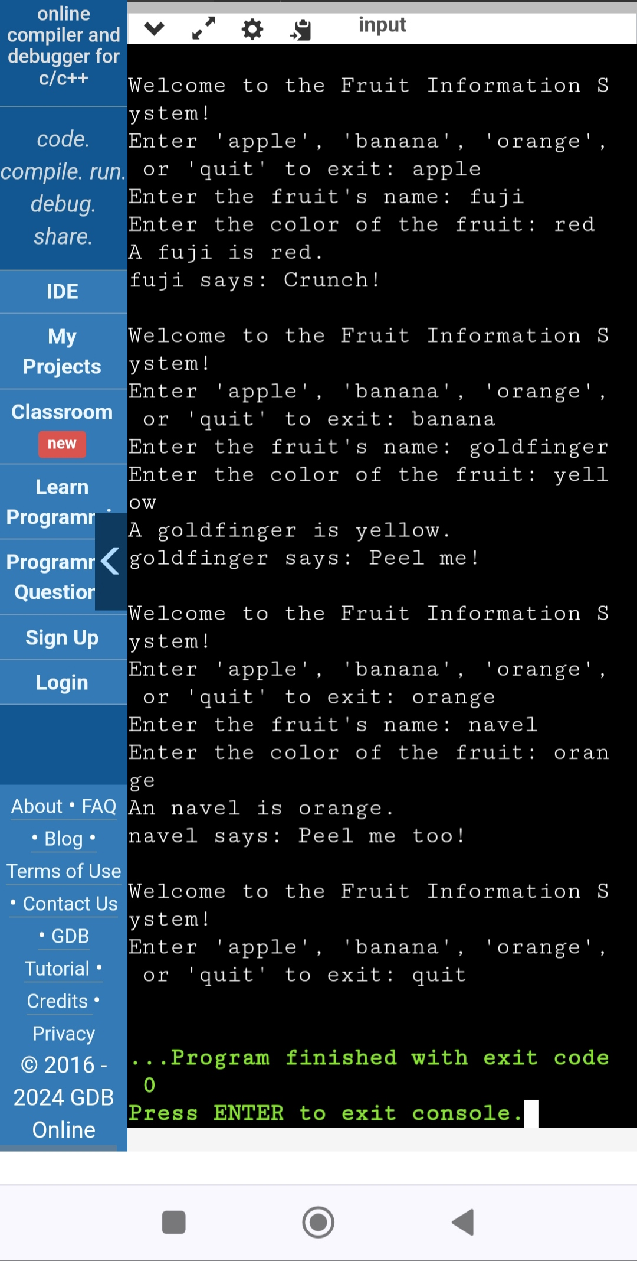
Output

Discretion
The provided code for the fruits Information System effectively demonstrates the four fundamental principles of Object-Oriented Programming (OOP): encapsulation, abstraction, inheritance, and polymorphism. By running the program, users can experience how these principles are applied in practice.

Code
from abc import ABC, abstractmethod

# Encapsulation: Defining the Fruit class with private attributes
class Fruit(ABC):
def __init__(self, name, color):
self.__name = name
self.__color = color

# Abstraction: Defining an abstract method that must be implemented by subclasses
@abstractmethod
def speak(self):
pass

# Encapsulation: Getter methods to access private attributes
@property
def name(self):
return self.__name

@property
def color(self):
return self.__color

# Inheritance and Polymorphism: Dog class inherits from Pet
class Apple(Fruit):
def __init__(self, name, variety):
super().__init__(name, variety)

def speak(self):
return "Crunch!"

# Inheritance and Polymorphism: Cat class inherits from Pet
class Orange(Fruit):
def __init__(self, name, color):
super().__init__(name, color)

def speak(self):
return "Peel me"

# Inheritance and Polymorphism: Fish class inherits from Pet
class Banana(Fruit):
def __init__(self, name, type):
super().__init__(name, type)

def speak(self):
return "Peel me too!"

def get_fruit_info():
name = input("Enter the fruit's name: ")
color = input("Enter the color of the fruit: ")
return name, color

def get_apple_info():
name, color = get_fruit_info()
variety = input("Enter the variety of the apple: ")
return name, variety

def get_orange_info():
name, color = get_fruit_info()
return name, color

def get_banana_info():
name, type = get_fruit_info()
return name, type

def main():
while True:
print("\nWelcome to the Fruit Information System!")
choice = input("Enter 'apple', 'orange', 'banana', or 'quit' to exit: ").lower()
if choice == 'quit':
break

if choice == 'apple':
name, variety = get_apple_info()
apple = Apple(name, variety)
print(f"{apple.name} is a {apple.color} {apple.species}.")
print(apple.name, "says:", apple.speak())

elif choice == 'orange':
name, color = get_orange_info()
orange = Orange(name, color)
print(f"{orange.name} is a {orange.color} {orange.species}.")
print(orange.name, "says:", orange.speak())

elif choice == 'banana':
name, type = get_banana_info()
banana = Banana(name, type)
print(f"{banana.name} is a {banana.color} {banana.species}.")
print(banana.name, "says:", banana.speak())

else:
print("Invalid choice. Please enter 'apple', 'orange', 'banana', or 'quit'.")

if __name__ == "__main__":
main()
User Guide
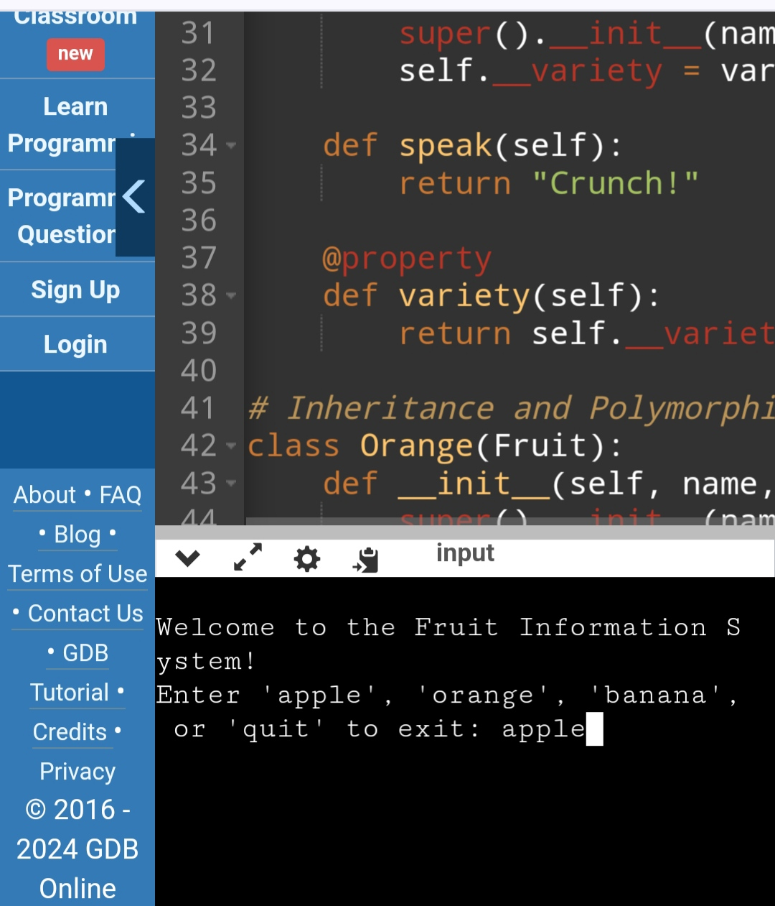
Step - 1: Choose the type of fruit you have.

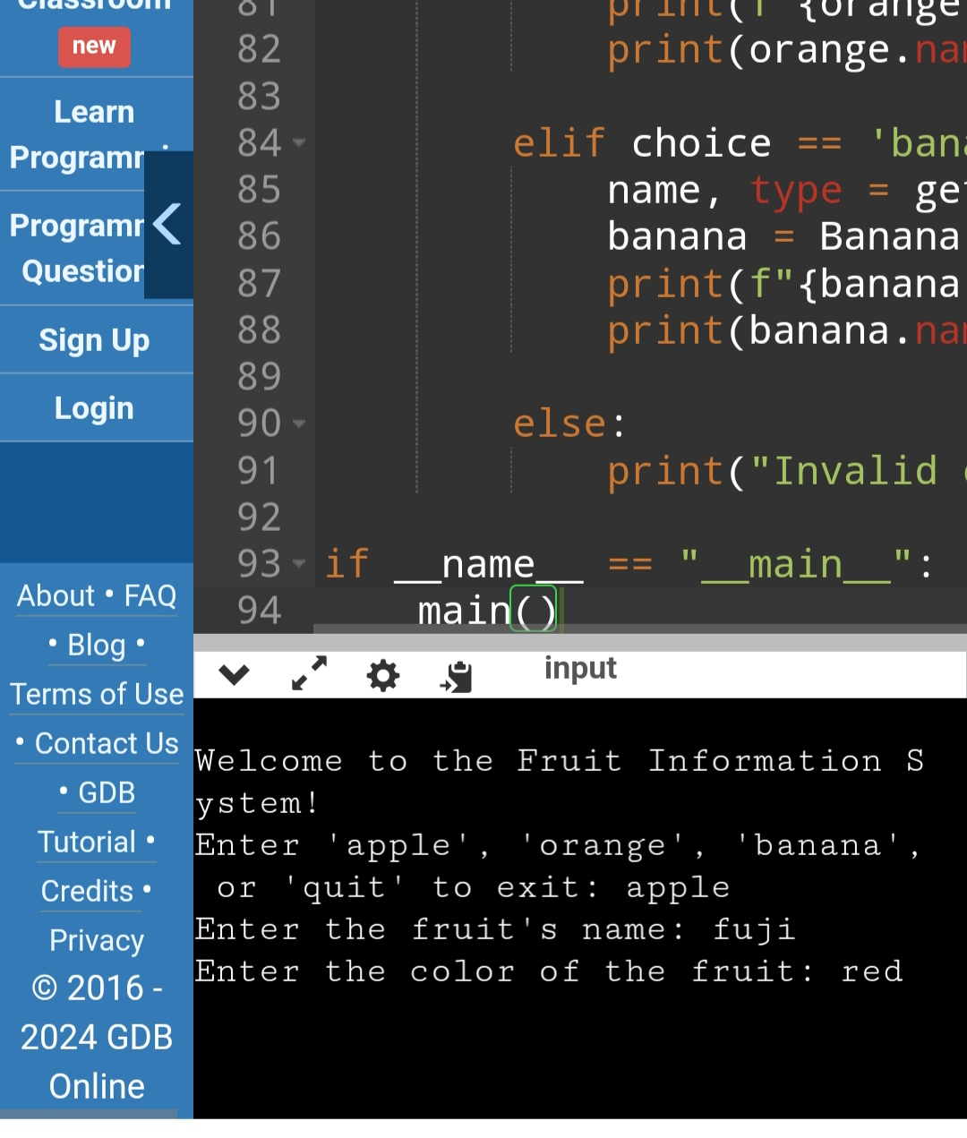
Step - 2: Fill the the name, and color of the apple you have.

Reference
Online GDB: https://onlinegdb.com/3FQzAVA62
Encapsulation: https://www.datacamp.com/tutorial/encapsulation-in-python-object-oriented-programming
Abstraction: https://www.analyticsvidhya.com/blog/2024/02/understanding-abstraction-in-python-simplifying-complex-concepts/#:~:text=Abstraction%20in%20Python%20refers%20to,be%20shared%20among%20multiple%20classes.
Inheritance: https://www.datacamp.com/tutorial/super-multiple-inheritance-diamond-problem?utm_source=google&utm_medium=paid_search&utm_campaignid=19589720824&utm_adgroupid=157156376311&utm_device=m&utm_keyword=&utm_matchtype=&utm_network=g&utm_adpostion=&utm_creative=698229374827&utm_targetid=dsa-2218886984100&utm_loc_interest_ms=&utm_loc_physical_ms=9061352&utm_content=&utm_campaign=230119_1-sea~dsa~tofu_2-b2c_3-row-p2_4-prc_5-na_6-na_7-le_8-pdsh-go_9-na_10-na_11-na-may24&gad_source=1&gclid=CjwKCAjwupGyBhBBEiwA0UcqaJNB40zD0QNTj66zAaIi-F0xiWpmmGenbPCCd2xZiHT_jQmrVpWusBoCWbYQAvD_BwE
Polymorphism: https://www.geeksforgeeks.org/polymorphism-in-python/amp/

